**IDEATION PHASE**

**LITERATURE SURVEY**

|  |  |
| --- | --- |
| **Date** | October 11, 2022 |
| **Team ID** | PNT2022TMID03743 |
| **Project Name** | A Novel Method for Handwritten Digit Recognition System |
| **Maximum Marks** | 2 marks |

|  |  |  |  |  |  |
| --- | --- | --- | --- | --- | --- |
| **S.N O** | **TITLE** | **PROPOSED WORK** | **TOOLS USED/ ALGORITHM** | **TECHNOLOGY** | **ADVANTAGES/DISADVANT AGES** |
|  |  | Handwriting recognition is one |  |  | The system not only |
| 1 | A Novel Method for Handwritten Digit  Recognition Using Image Processing and Neural Networks | of the compelling research works going on because every individual in this world has their own style of writing. MNIST data set is widely used for this recognition process and it has 70000 handwritten digits. We use Artificial neural networks to train these images and build a deep learning model. | * Random Forest, * J48 * Random Tree * Naive Bayes, * Support vector Machine, * Bayesian Network * Multilayer   Perceptions | * Optical Character Recognition * (OCR) * Deep Learning, * Machine   Learning   * Artificial Neural Networks | produces a classification of the digit but also a rich description of the instantiation parameters which can yield information such as the  writing style  The generative models can perform recognition driven segmentation |
| 2 | Handwritten Digit  Recognition Using Image Processing and Neural Networks | It can detect handwritten digits from a scanned image of an input form by using Neural network technique.several data has been trained to neural network based AI engines to detect the image . handwritten digit will be given as sample input in to the system , the output array will automatically give the digit whose corresponding match value is detected. | * Fourier transformation * Support Vector Machine (SVM) ● Histogram | ● Artificial Neural network | It only requires one time training of the neural network whereas in cited methodologies whenever there is an image to process all steps are repeated again and again for image pre- processing |

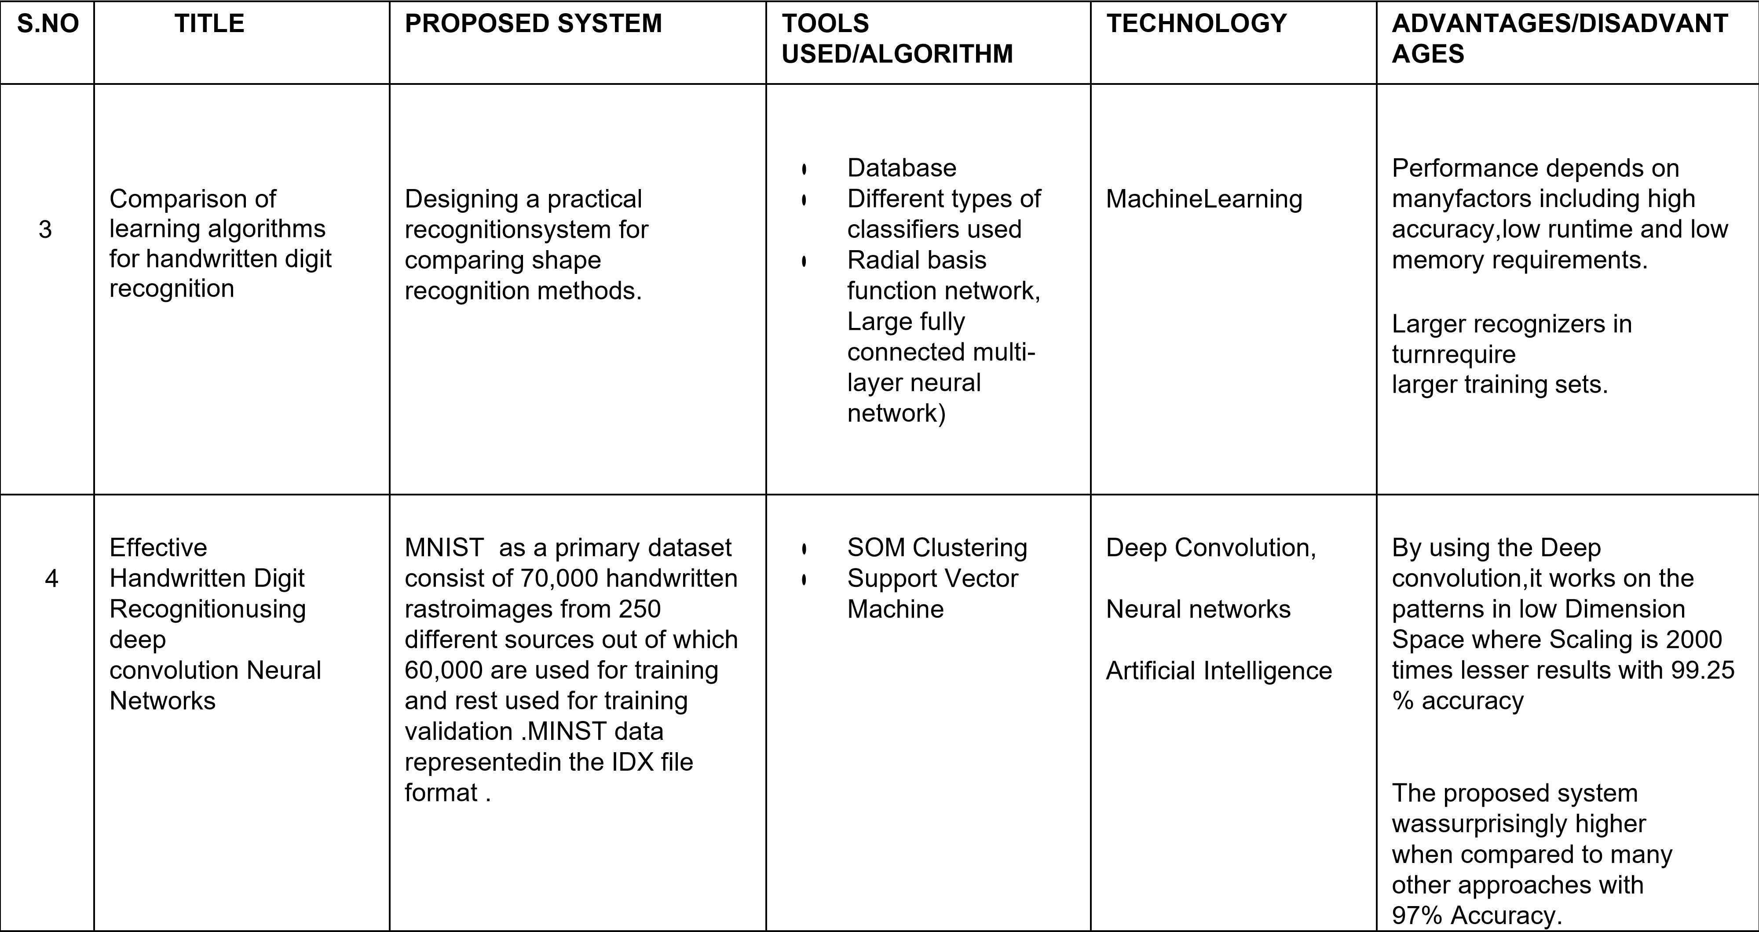

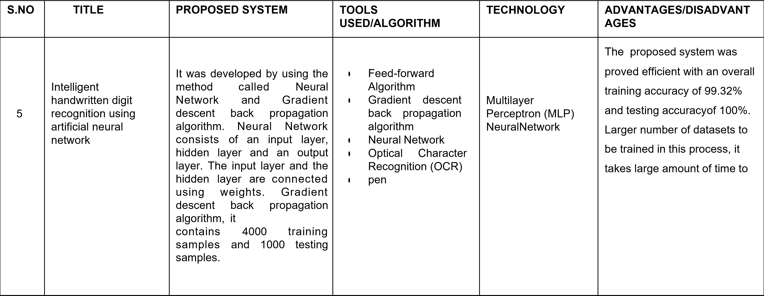

A novel method for

6 handwritten digit recognition using deep learning

The MNIST database has been used for that which is already divided into training set of 60,000 examples and test of 10,000 example. The training algorithm used is Convolution Neural Network. This will prepare the trained model which will be used to classify the digits present in the test data.

* Convolution Neural ● Deep

Network Learning

* Multi-Layer ● Machine Perceptron Learning
* TensorFlow

By using the Convolution Neural Network, we can able to get an accuracy of 95.72%.

Sometimes it doesn’t provide the appropriate solution based on input